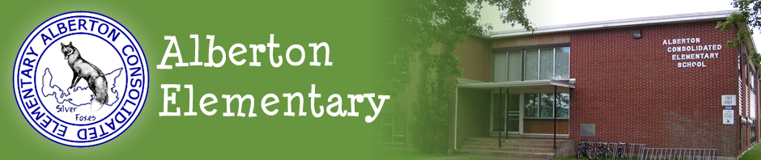

www.alberton.edu.pe.ca
354 Church Street
Phone: 902-853-8617 fax: 902-853-8608 March, 2021
IMPORTANT DATES  March 5 –Parent Teacher Interviews (NO CLASSES)  March 15-19 – March break  April 2-Good Friday (NO CLASSES)  April 5-Easter Monday (NO CLASSES)  April 16-School goals Day(NO CLASSES)  April 30-PVC second vaccine for grade 6 | Facebook.com Alberton Elementary  Facebook.com/Alberton Home & School

Kindergarten Information
Information will be sent out in the coming weeks around information and plans for Early Years Evaluations, Parent Information Session, Welcome to Kindergarten and Kindergarten Orientation Day. Stay tuned!

REGISTRATION FOR KINDERGARTEN
If you have missed registration week, it is not too late! Children must be 5 years old by December 31, 2021, in order to be eligible for Kindergarten in September 2021.
Please contact the office at 902-853-8617.

Parent Support for Digital Tools
If parents are looking for support in helping their students access digital tools and platforms from home, a Support page is linked here: https://sites.google.com/cloud.edu.pe.ca/assistance/home . This page provides “how to” information and videos for parents on Google account access, Google Sites, Google Classroom, Google Meet, Sora and other resources.

Visitors
With our ongoing focus on student and staff safety, visitors in schools will be reduced and will be encouraged to wait outside the school. We encourage parents and other visitors to limit the number of visits to schools. If you have to come into the school you MUST wear a mask, sanitize after entering the school and sign-in. Thank you for your co-operation with this.

Staff Appreciation Week
A special Thank You to the Home and School and many parents for their generosity during Staff Appreciation Week. It was well received and appreciated.

Healthy School Food Program
If you order lunches from the Healthy School Food Program, please remember to send utensils daily with your child as these are no longer provided.

Absences
Parents and guardians are reminded to please contact the school in the event that your child(ren) is going to be absent from school. The school is available to take calls between 8:00 am – 3:30 pm. It is important that we are logging accurate information regarding absences and this time of year we are also monitoring the level of illness in our schools. Thank you

Dressing for the Weather
Spring has almost arrived! However the weather remains brisk and cold on some days and rather wet on others. Please ensure your child is dressed warmly for the weather with hats, mitts, scarf, rubber boots, warm winter coat and snow/splash pants. Please be sure to pack an extra set of clothes in the event that your child gets wet and a plastic bag to put wet clothing in.

Home and School News, March 2021

1. 68th Annual Meeting
Mark your calendar! You are invited to attend the Annual Meeting, virtually on Zoom, Monday, May 10, 2021, 6:30 p.m. Home and School Associations are encouraged to appoint up to five voting delegates to represent their school with all parents, educators/school staff and students welcome to attend. Registration information will be posted online soon.

2. Annual reports due Mar. 19
Annual Report submission date has been changed to March 19th. Thank you to those who have submitted annual reports. The Federation decided to hold the AGM in May which allows more time for presidents/co-chair to write and submit their reports. Please email reports in a word doc or paste in email message to: peihsf@edu.pe.ca

3. Board of Directors Nominations
The P.E.I. Home and School Federation is the umbrella organization of Home and Schools across P.E.I., and is overseen by a volunteer board elected by delegates from member Home and Schools. Every year at the annual meeting elections are held for vacant positions on the board, and members are encouraged to nominate candidates who, in your opinion, have the necessary qualifications to do the work of the provincial Federation. Access the nomination form here.

4. Volunteer / Life Membership Awards
A Home and School volunteer is recognized annually for their efforts in their local school with the Steve McQuaid Volunteer of the Year Award. A Home and School Life Member is someone who has contributed both locally and provincially. You are invited to review awards’ criteria and submit nominations by March 19 Review nomination information here.

5. Consultations for an Elected School Board Model
The government is looking for your input on the best elected school board model for English schools in the Public Schools Branch. Have a say and fill out the online survey here or submit to the government in writing by Mar. 11. More details here.

Community news:
- EDUCATION SAVINGS FOR CHILDREN offered by the federal government = Families are encouraged to sign up for Canada Learning Bond (CLB). News release: Government of Canada invests in making post-secondary education more affordable to all The CLB consists of up to $2,000 that the Government of Canada deposits directly into Register Education Savings Plans (RESP) for children from low-income families, born on or after January 1, 2004, to help pay for their post-secondary education. This includes $500 for the first year of eligibility and $100 for each subsequent year of eligibility, until the calendar year they reach the age of 15. Visit: canada.ca/education-savings
- POWERSCHOOL = Island students, parents and teachers will have a more accessible and up-to-date way to keep track of student information later this year. P.E.I. schools moving away from StudentsAchieve, older data systems this fall
• PROTECT CANADIAN KIDS: Nicotine levels in e-cigarettes must be reduced to protect Canadian kids . Kids who try vaping products are at high risk of becoming addicted users. By the time kids finish high school, 1/3 are vaping. Health Canada is proposing to limit the amount of nicotine that can be sold in vaping liquids to 20 mg/ml. This is the level that the European Union adopted several years ago. The vaping rates among young people in the European Union are far lower than those in Canada. In Canada, some e-cigarettes have nicotine levels of 59 or 57 mg/ml, placing Canadian kids at risk and contributing to very high levels of youth vaping in Canada. You can help protect Canadian kids by letting Health Canada know that you support this important regulation. For more information: info@ProtectCanadianKids.ca

